From
“A Summary of the Christian Faith”
by David Chytraeus (1568)

What is the High Priest?

The High Priest, or Christ, is the person whom God called immediately and anointed with the fullness of the Holy Spirit to bring forth the Gospel from the hidden bosom of the heavenly Father and to pray on our behalf. He has the promise that He is certainly heard and that He offers the sacrifice, namely, Himself, by which sacrifice He earns forgiveness of sins, righteousness and eternal life for the entire Church.
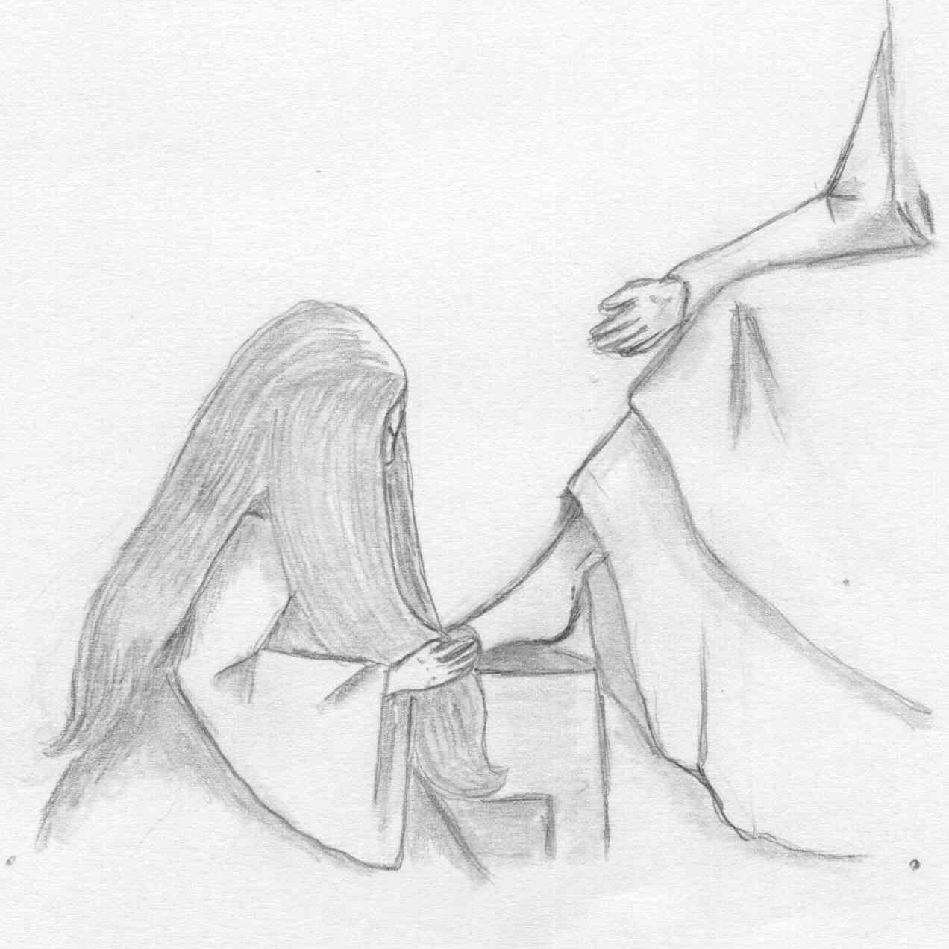
Who is this who even forgives sins?
Our Redeemer Lutheran Church
403 South Hayes
Emmett, Idaho 83617 Church: 208-365-5231

Pastor: Rev. Michael L. McCoy
parsonage: 208-365-5214
email: mmccoy19@earthlink.net
www.scholia.net – the website for:
Good News for the Diaspora!
scholia.net publishing – Where the Word is not Bound
Predici in limba romana – (Sermons in Romanian)
The artwork is by Sharon Geiser. Permission to use this copyrighted graphic is limited to congregational use. The quotation above is by David Chytraeus and is from his 1568 work A Summary of the Christian Faith. The English translation is by Rev. Dr. Richard Dinda and is published by Repristination Press. For information on this book and other books by Repristination Press see the website below.

This bulletin cover provided by www.scholia.net and is made available without cost.

27 June Anno Domini 2004

Trinity 3 / Pentecost 4

To place the graphic on this page:
Copy the graphic on the previous page.
Click on the open space above and a graphic box should appear. Paste the graphic.

Change this frame and the box above by clicking the body of the text and adding the particulars. (See the previous page for an example.)
The artwork is by Sharon Geiser. Permission to use this copyrighted graphic is limited to congregational use. The quotation above is by David Chytraeus and is from his 1568 work A Summary of the Christian Faith. The English translation is by Rev. Dr. Richard Dinda and is published by Repristination Press. For information on this book and other books by Repristination Press see the website below.

This bulletin cover provided by www.scholia.net and is made available without cost.

27 June Anno Domini 2004
Trinity 3 / Pentecost 4
Who is this who even forgives sins?

From
“A Summary of the Christian Faith”
by David Chytraeus (1568)

What is the High Priest?

The High Priest, or Christ, is the person whom God called immediately and anointed with the fullness of the Holy Spirit to bring forth the Gospel from the hidden bosom of the heavenly Father and to pray on our behalf. He has the promise that He is certainly heard and that He offers the sacrifice, namely, Himself, by which sacrifice He earns forgiveness of sins, righteousness and eternal life for the entire Church.

